HITTING THE HEADLINES WITH YOUR FUNDRAISING
To help give your fundraising a boost, we’ve provided you with a template press release to send to your local paper. Local press like to hear about people in the community doing their bit for charity, and getting your fundraising covered in your local paper really helps raise awareness of the charity and could encourage even more people to sponsor you!

Check out the handy tips below to increase your chances of getting your story in the paper.
How to use the template press release:
- Simply fill in your details on the press release, using the examples (written on the press release in purple) as a guide. Make sure you delete all the instructions when you’re done!
- Call your local paper and ask to speak to the news desk – they will be able to tell you who to email the press release to.
- Send your press release, along with a photo of you (see tips below). A great photo can really make a story.
- Follow up with another phone call a couple of days later – don’t be shy!

Taking a great photo:
- Your photo needs to be print quality – this means between 1MB and 4MB, or 300dpi. If in doubt, set your camera to its highest setting.
- Tell the story and show exactly what your fundraising challenge is – eg, you on your bike (if a cycle challenge) – and wear your Great Ormond Street Hospital Children’s Charity top (if you have one)
- Make sure you’re in the foreground and preferably centred. Brightly lit (eg, outside in the garden or park) and brightly coloured photos work well.
- If you’re outside, make sure the sun is behind the person taking the photograph.
- If you are not sure please take a look at the following examples or your local press to get inspiration.

Good Example Bad Example
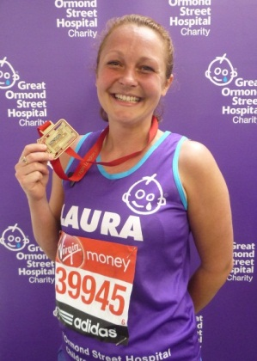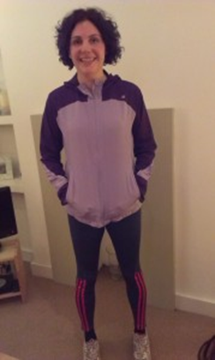

PRESS RELEASE [INSERT DATE]
(NAME OF SALON, TOWN) HOLDS [FUNDRAISING ACTIVITY] TO SUPPORT THE HAIRRAISING APPEAL FOR GREAT ORMOND STREET HOSPITAL CHILDREN’S CHARITY
[DATE] [NAME OF SALON, TOWN] will be organising a [NAME OF FUNDRAISING EVENT & A BRIEF DESCRIPTION] on [DATE] to raise vital funds for Great Ormond Street Hospital Children’s Charity as part of the HAIRraising appeal.
Founded in 2010 by hairdressing entrepreneur John Frieda, the HAIRraising appeal invites the hairdressing community to come together to help raise vital funds for the charity.
The money raised by the appeal will go towards the hospital’s brand new Respiratory Unit. The new Unit will provide more space and privacy for families, including spacious bedrooms with en suite bathrooms and a comfortable bed which will enable parents or carers to sleep by their child’s bedside overnight as well as a high dependency unit which will provide ample space for medical equipment.
(SALON SPOKESPERSON- ENTER NAME) said: “[INSERT QUOTE]”
Please add a brief quote about why you are getting involved, what you aim to achieve and what it means to you. E.g. “We are delighted to be able to raise money for this fantastic charity and we aim to raise £xx”
To show your support you can donate to [Please include a just giving link or directions to donate via the salon]
For more information on the HAIRraising appeal and Great Ormond Street Hospital Children’s Charity please visit www.gosh.org/HAIRraising.
-Ends-
For media enquiries, please contact:
[INSERT CONTACT NAME AND PHONE NUMBER]
Notes to Editors:
About Great Ormond Street Hospital Children’s Charity
Great Ormond Street Hospital is one of the world’s leading children’s hospitals with the broadest range of dedicated, children’s healthcare specialists under one roof in the UK.

The hospital’s pioneering research and treatment gives hope to children who are suffering from the rarest, most complex and often life-threatening conditions, from across the country and abroad.
Great Ormond Street Hospital Children's Charity needs to raise £50 million a year to help rebuild and refurbish Great Ormond Street Hospital, provide vital up-to-date equipment and fund research into better treatments for the children. You can help us to provide world class care for our patients and families. For more information visit www.gosh.org
About the new Respiratory Unit:
The new Respiratory Unit is scheduled to open in 2016
The unit will provide more space and privacy for families, including spacious bedrooms with en suites which will enable parents or carers to sleep by their child’s bedside overnight, and a high dependency unit will provide parents and carers to rest in comfort throughout the day and also provide ample space for medical equipment.

